Novel Study - Term 1 2017
The Lion the Witch and the Wardrobe
by C. S. Lewis
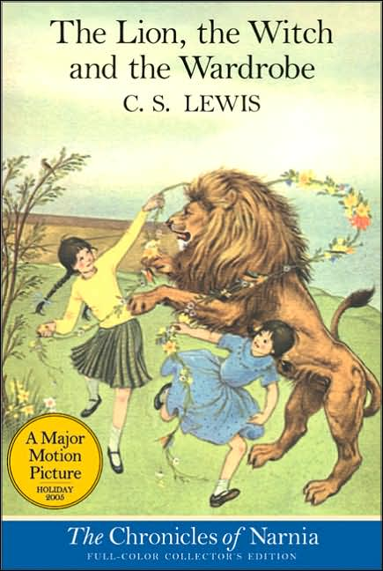

Four siblings are sent away from home during the blitz of WWII. They are sent to be watched over by Professor Kirke, who owns a massive mansion. Once there, they stumble upon an enormous wardrobe which transports them to the world of Narnia.
Narnia itself was once a peaceful realm filled with talking animals, fauns, giants and dwarves that is now under a cursed eternal winter by the villainous White Witch.
With aid from the majestic lion Aslan, the four lead Narnia into an
all - out war as they fight to outwit the Witch and restore peace to the land.
PART ONE
Who was C.S. Lewis? Write a short biography about him.

.

Record the individual character traits for each of the four children:
.

Characteristics and Values
Peter | Susan | Edmund | Lucy
Use this Venn diagram to compare and contrast two of the characters from above.

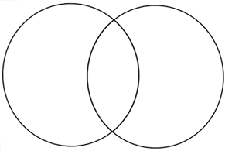

Illustrate your favorite part of the book and write a short passage explaining the events.

Picture | What is happening?

PART TWO

You must complete four activities. Two of the activities must be from List A and two activities must be selected from List B. Circle your choices.

List A
1. Diary Writing Pretend that you are a character in the novel. Write three diary entries that tell your experiences in Narnia.

2. Character Web Identify all the different characters in the novel.

3. Ending Rewrite a different ending to your story. Be imaginative and different.

List B
!. Excitement Graph Create an excitement graph. You must include a minimum of 5 events. Give each event a rating of high, medium or low. Be sure to name each event.

2. Book Cover Redraw a different cover for your novel.

3. Put yourself in the story. Write an extract that includes you as one of the characters. What happens?

Extension: - The faun is a fascinating creature found in many folklore stories. Find out more about this mythological beast. Then, make a model, draw one, make an i-stop clip……………be creative. You decide!!!!

